L O R N A

A L V A R A D O
F A S H I O N D E S I G N E R

PROFILE EDUCATION

Let me introduce myself, I am a fashion designer who has 7 years of experience in this job. I am very experienced in various fashion styles for all seasons and I have made various models for men and women for a world famous brand.

SKILLS

Professional Teamwork Flexibility
Creativity Organitation
Fashion School - Aldenaire University | 2018 - 2023

Already made all the styles for all seasons and made all the designs to be more sold.

Fashion School - Aldenaire University | 2018 - 2023

Already made all the styles for all seasons and made all the designs to be more sold.

Fashion School - Aldenaire University | 2018 - 2023

Already made all the styles for all seasons and made all the designs to be more sold.

EXPERIENCE

Salford Company - Fashion Manager | 2018 - 2023

Already made all the styles for all seasons and made all the designs to be more sold.


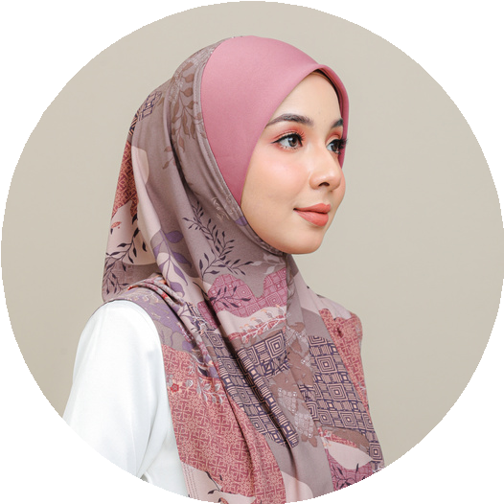
123 Anywhere St., Any City,
ST 12345
+123-456-7890
www.reallygreatsite.com
hello@reallygreatsite.com
Salford Company - Fashion Manager | 2018 - 2023
Already made all the styles for all seasons and made all the designs to be more sold.

